**How to make power point like JS validation library presentation**

Before start let’s see the output first:-

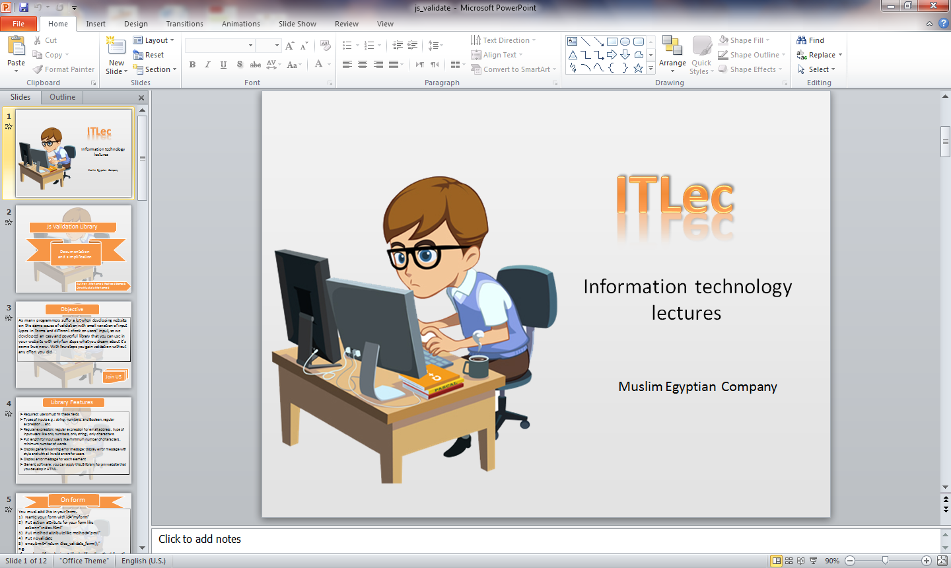

To make this slide follow these steps:-

1. Double click on PowerPoint 2010 it will be open like this...

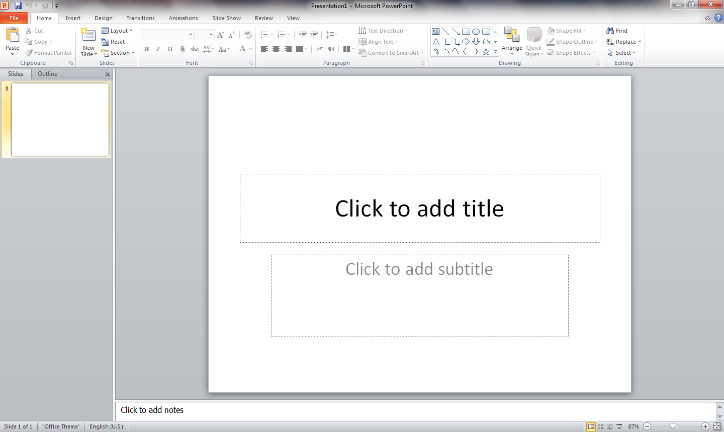

1. Delete all textboxes that you see be selecting them then press delete.
2. Right click on the slide in slides pane then choose format background

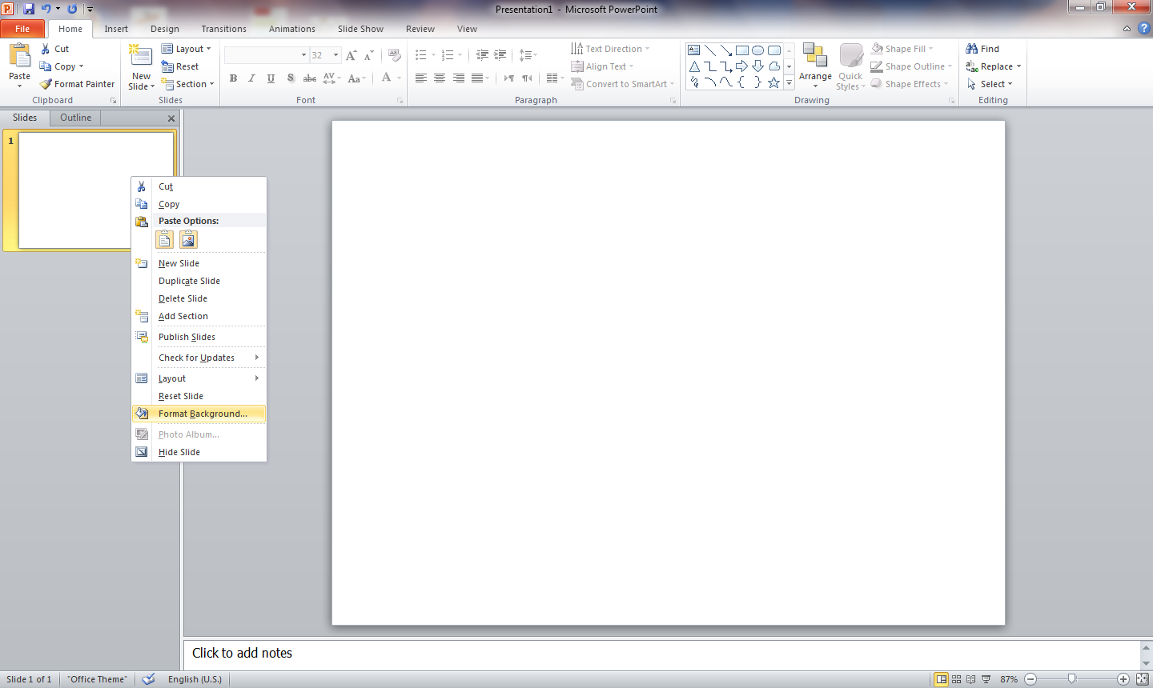

1. It will appear dialogue box >> from fill tab>> choose gradient fill >>choose linear and put the colors that you want with a little variations between dark and light degrees.

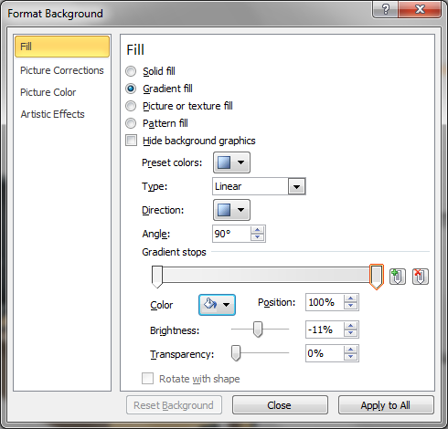

1. Add your image that you want I used this image.



1. Then add your company name with different style that you want you can choose from text effect styles.
2. Insert textbox then write your text.
3. Select textbox then choose the style you want.

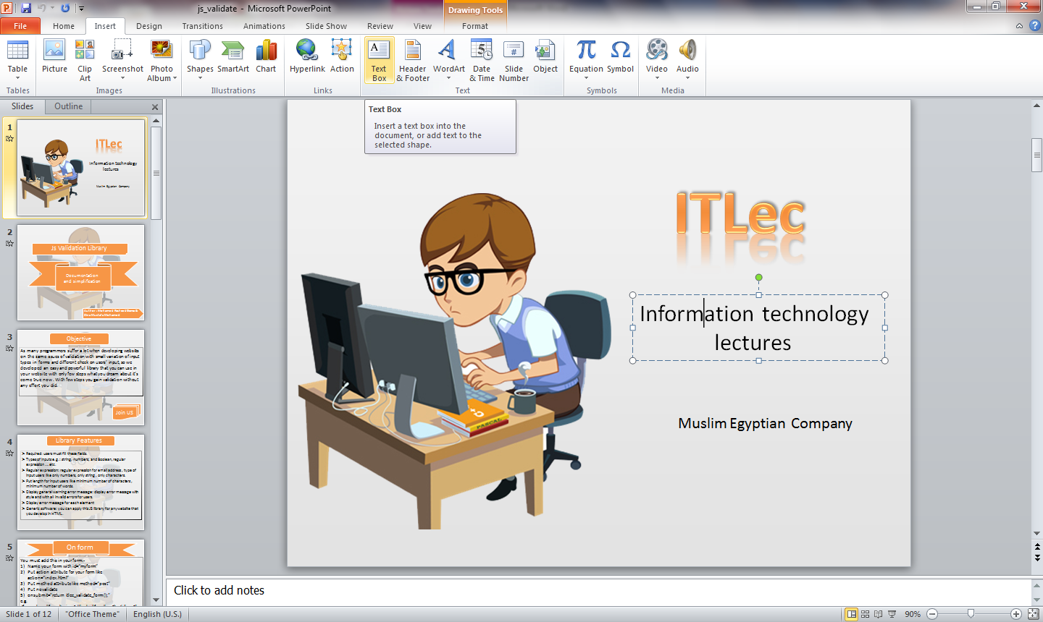

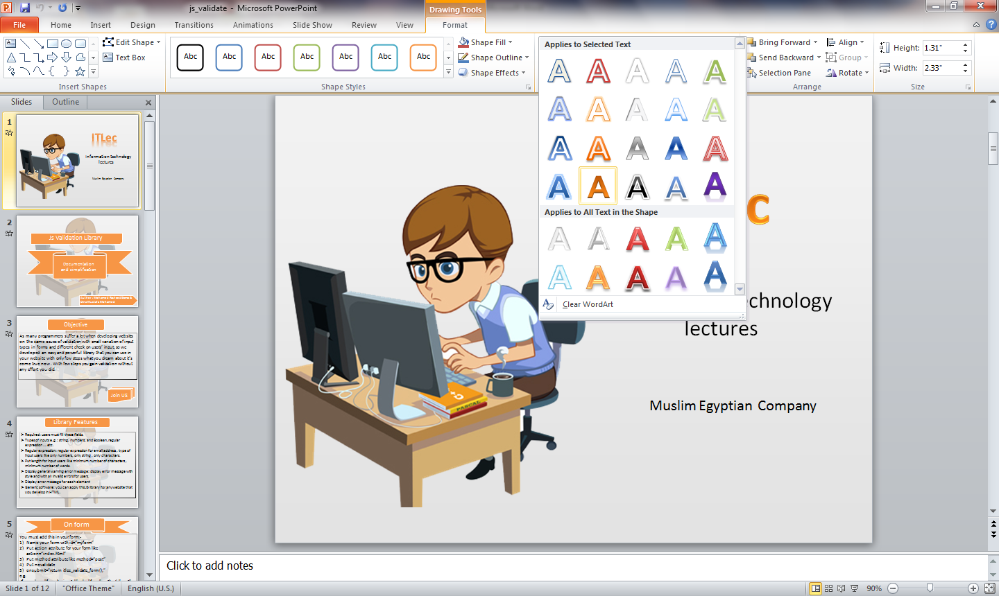

1. Select textbox then add reflection to your company name.

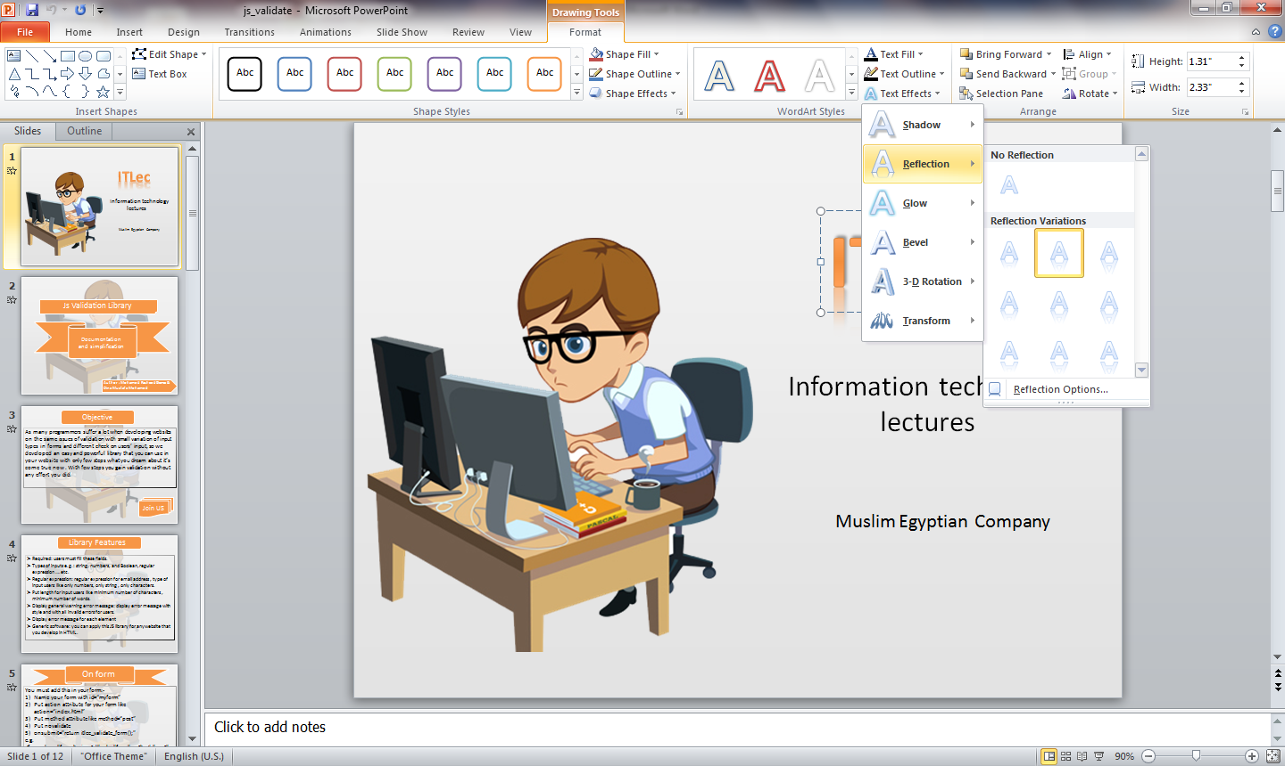

1. Then Insert textbox then write your text that you want to be appeared in your first slide.
2. Time to animate: two types animation for slides called transition you will find transitions tab in ribbon choose any animation you want to your slides.

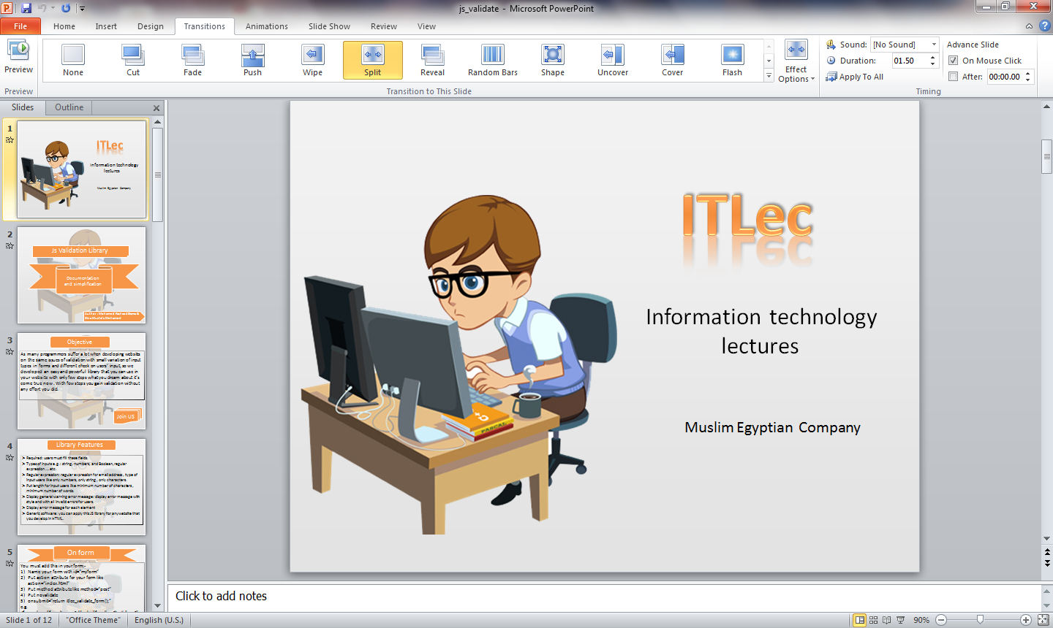

1. Animation for elements in slides by selecting the object then click on animations tabs and chooses any animation you like



For more details join us on ITLec.

I hope that help you to achieve your dreams to make your perfect presentation for your audience.

Thanks for your time, see you next time.